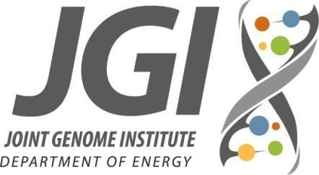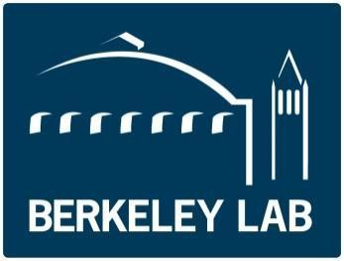
Technology Overview Workshop
Wednesday, March 14, 2018
Hilton Union Square, San Francisco

Administrative Contact:
Stephanie Canon StephanieCanon@lbl.gov 415-412-8478 mobile

Hilton Hotel Wifi: Network: Hilton-Events, Access Code: jgiuser2018

Agenda

Time | Topic | Location
8:30 – 8:45 | Len Pennacchio, Introduction to Genomic Technologies Workshop | Golden Gate 3&4
8:45 – 9:00 | Chris Daum, Sequencing Technologies | Golden Gate 3&4
9:00 – 9:15 | Juna Lee, Oxford Nanopore Sequencing | Golden Gate 3&4
9:15 – 9:30 | Matt Blow, Sequencing Applications | Golden Gate 3&4
9:30 - 9:45 | Ronan O’Malley, Functional Genomics | Golden Gate 3&4
9:45 - 10:00 | Lifeng Liu, Functional Genomics Case study from  Brachypodium | Golden Gate 3&4
10:00 - 10:30 | ~~Break~~
10:30 - 10:45 | Ben Cole, Plant Single-Cell Transcriptomics | Golden Gate 3&4
10:45 – 11:00 | Alex Copeland, Metabolomics Informatics | Golden Gate 3&4
11:00 -11:15 | Rex Malmstrom, Microscale applications group | Golden Gate 3&4
11:15-11:30 | Emiley Eloe-Fadrosh, Metagenomics capabilities | Golden Gate 3&4
11:30-11:45 | Sam Deutsch, DNA synthesis capabilities | Golden Gate 3&4
11:45-12:00 | Trent Northen, Metabolomics capabilities | Golden Gate 3&4

